SOC Login Monitoring Dashboard (Splunk)
Overview
These SOC login monitoring dashboards were built in splunk to provide real-time windows authentication login activities.
- Failed vs Successful Login Panel
This panel helps identify abnormal spikes in failed login which could indicate Brute-force attempts.
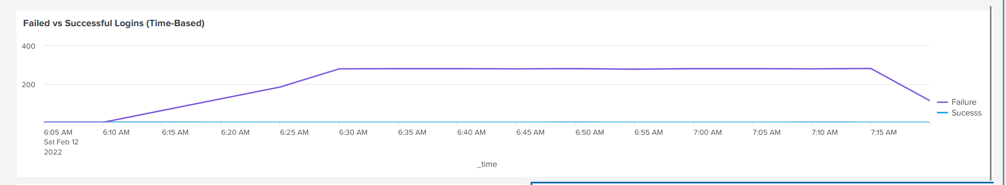
SPL Queries:
index=main sourcetype=csv "Event ID" IN (4624, 4625)
|eval status=if('Event ID'="4624","Sucesss","Failure")
| timechart count span=5m by status
- Top Source IP Panel
This panel helps highlight external hosts IP address generating authentication failures, allowing analysts to identify and block suspicious sources.
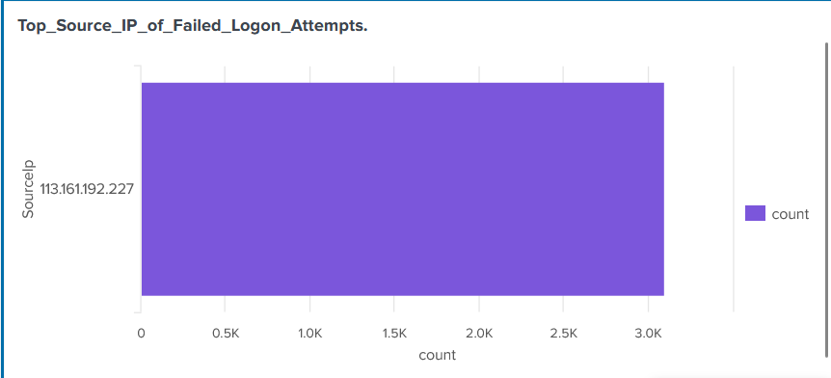

SPL Queries:
index=main sourcetype="csv" "Event ID"=4625 SourceIp=$Ip_token$
|stats count by SourceIp
|sort - count
|head 10

- Most Targeted Accounts panel
This panel reveals the top target accounts generating logon audit failures, allowing analysts to take proper measures to protect and monitor the account for suspicious activities.
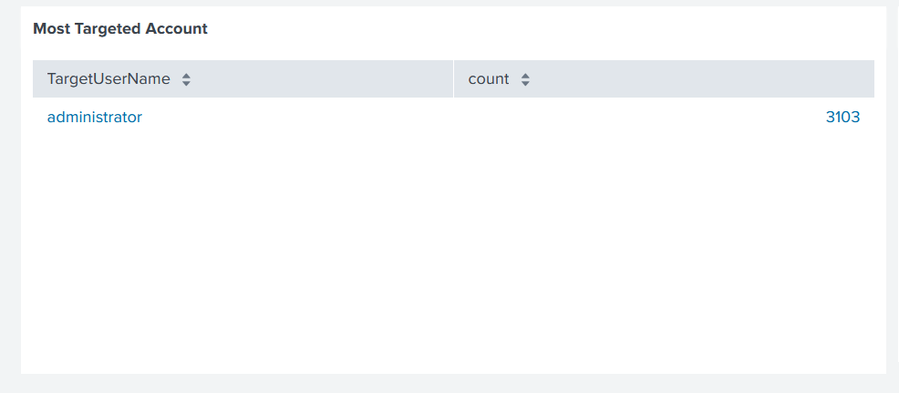
SPL Queries:
index=main sourcetype="csv" "Event ID"=4625 TargetUserName=$username_token$
|stats count by TargetUserName
|sort - count

- Full SOC Login Monitoring Dashboard
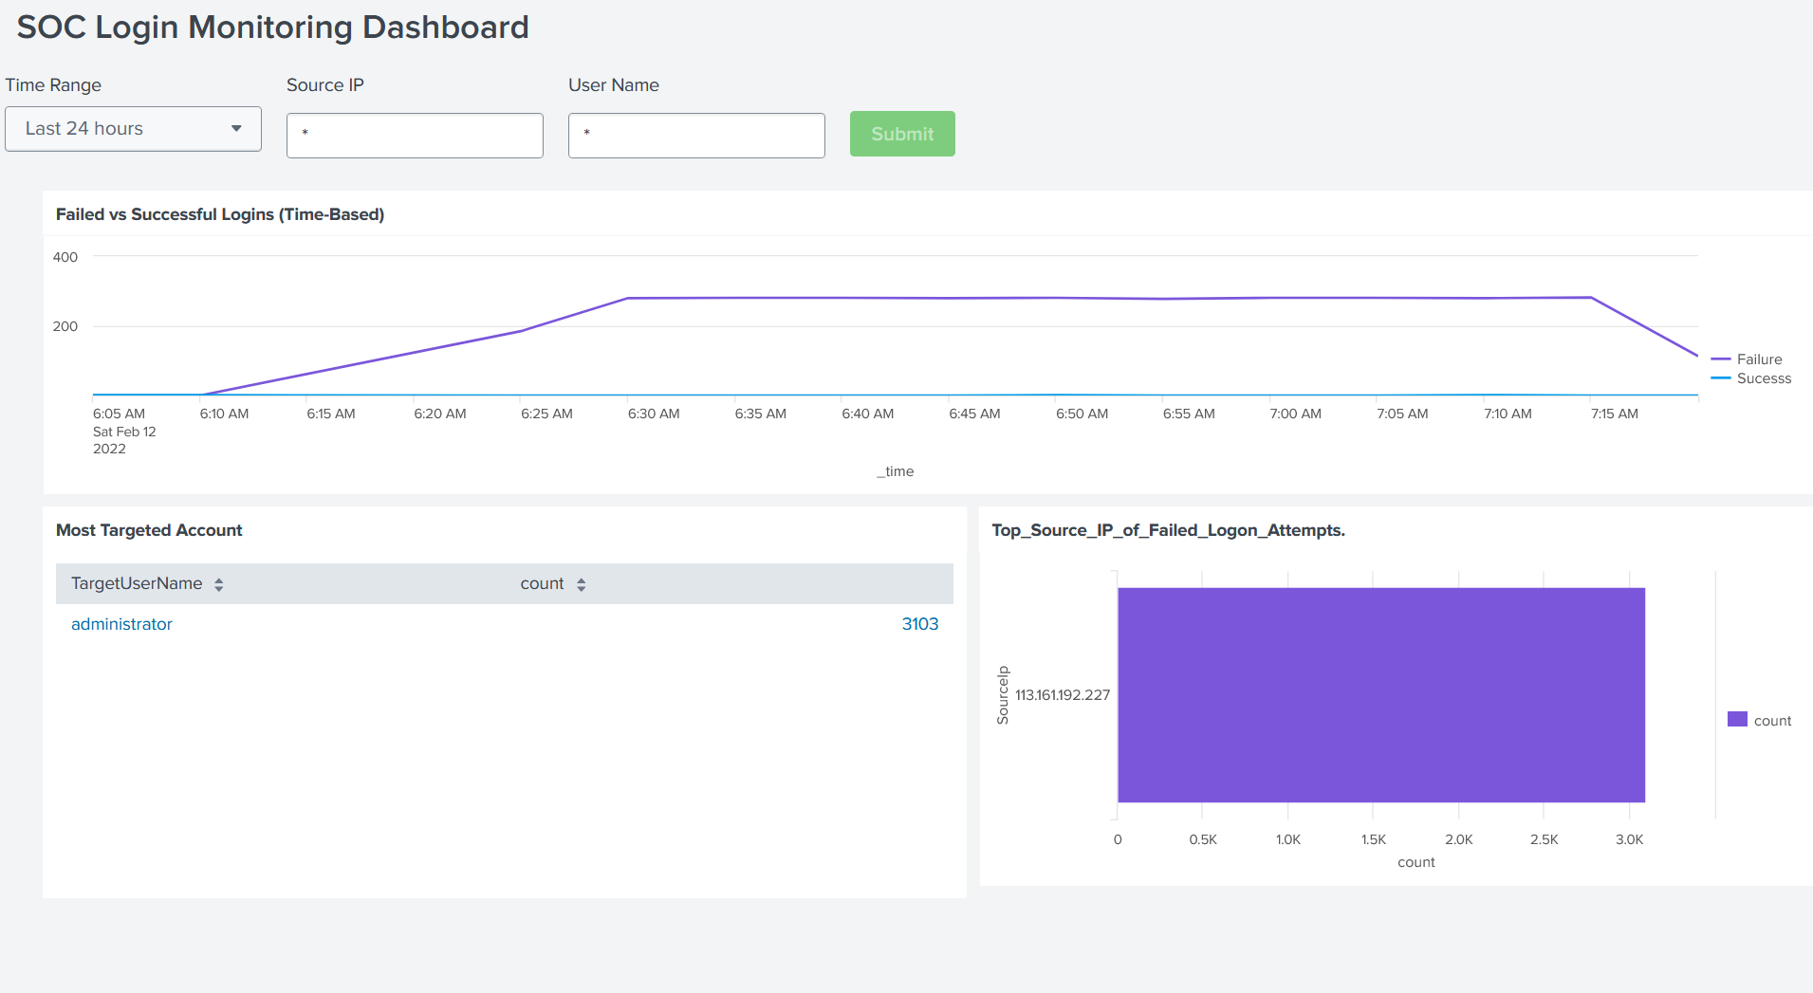
Summary
This Dashboard supports Tier 1 SOC analyst by enabling rapid detection, investigation and escalation of authentication based threats.

